Intellectual Need Task for Slopes of Secants and Tangents

Below is a graph of a function
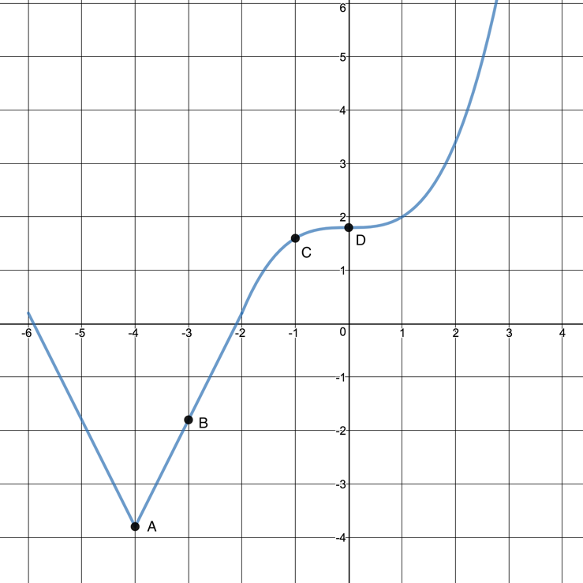

Which of the following shows the tangent line to the graph at point B?
    - 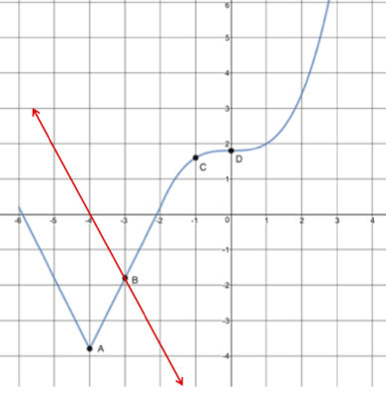
    - 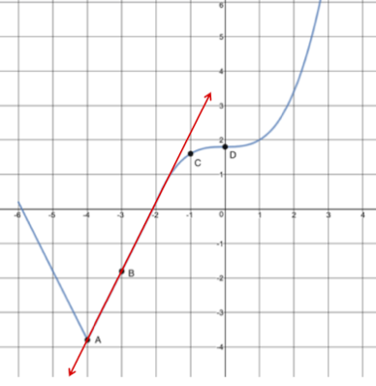
    - The tangent line exists, but isn’t either of the previous options
    - There is no tangent line to the graph at point B

What would tangent lines look like at points A, C, and D?

